

K4 CSF3133 REKA BENTUK ANTARA MUKA BERASASKAN WEB
LAB REPORT 3
SEMESTER 3

PREPARED FOR: ASSOC. PROF. TS. DR. WAN NURAL JAWAHIR
LAB ASSISTANT: MISS WAN FATIN

PREPARED BY: AKMA ASYIFA BINTI ZULKARNAIE
NO. MATRIC: S75186
SUBMISSION DATE: 29 OCTOBER 2025

3.2 Block and Inline Elements
Block.html
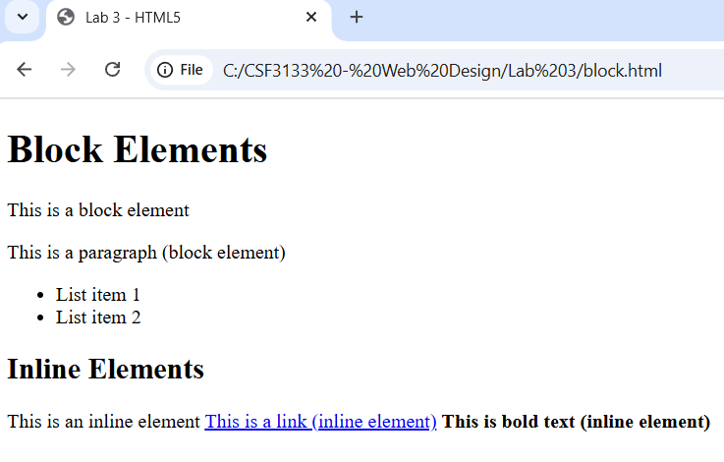

3.3 Using <div> to Organize Content
Div.html
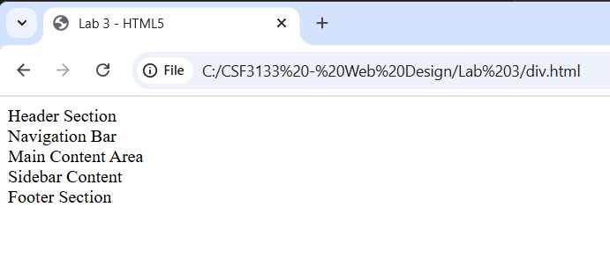
3.4 Understanding HTML Entities
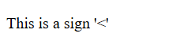

Entity.html
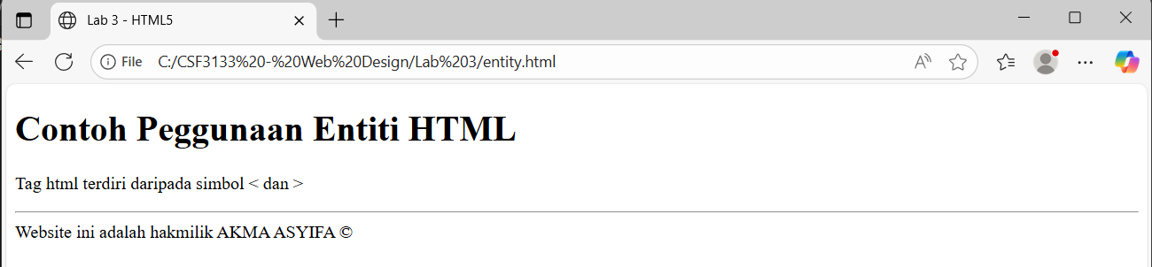

3.5 Hypertext Mark Up Language 5 (HTML5)
Intro5.html
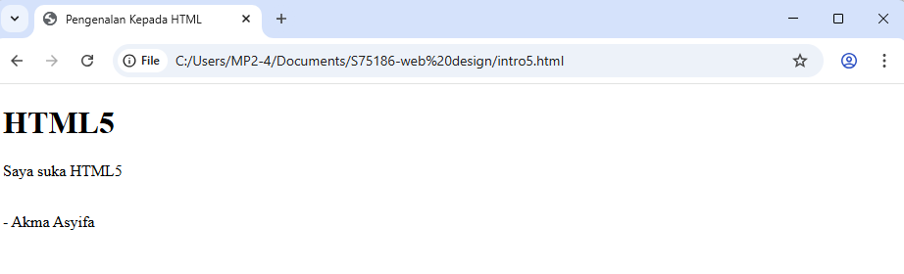

3.6 Form Elements in HTML5
3.6.1 Input Elements in HTML5
Input5.html
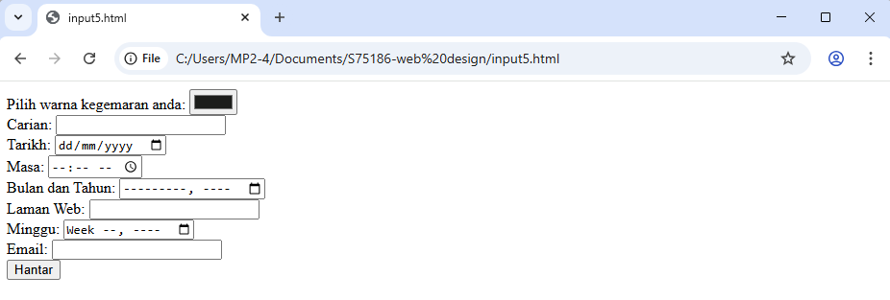
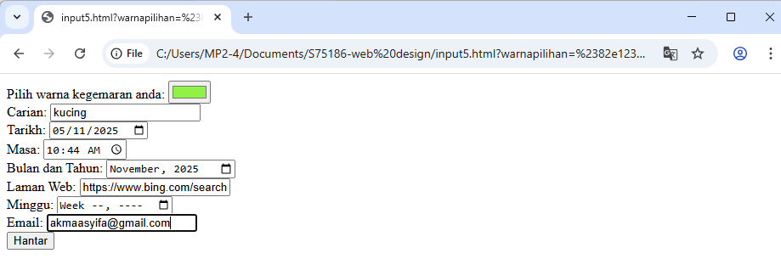
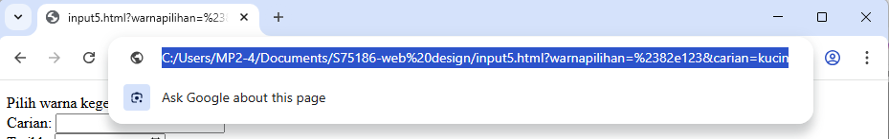

3.6.2 Attributes for Input HTML5
Inattribute5.html
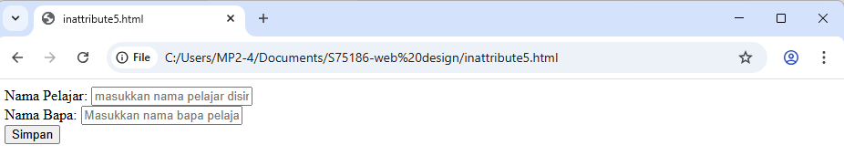
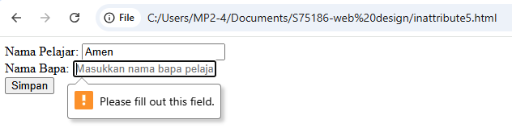
- When click on the ‘Simpan’ button, it didn’t save because the father name was required to fill in.
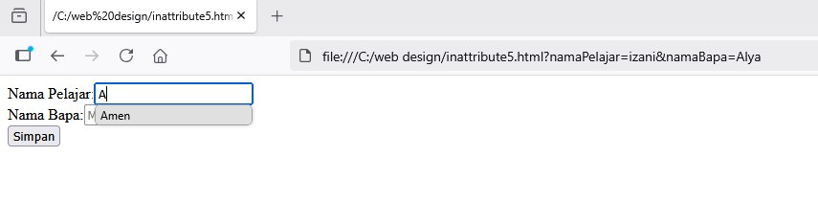
- It show the autocomplete work.

3.6.3 HTML5 <output> element
Output5.html
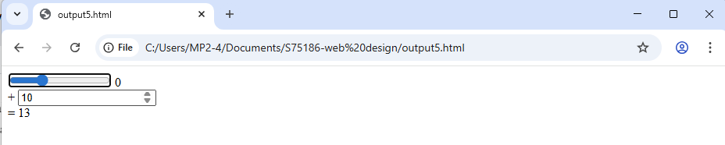

3.7 Lab Exercise 3
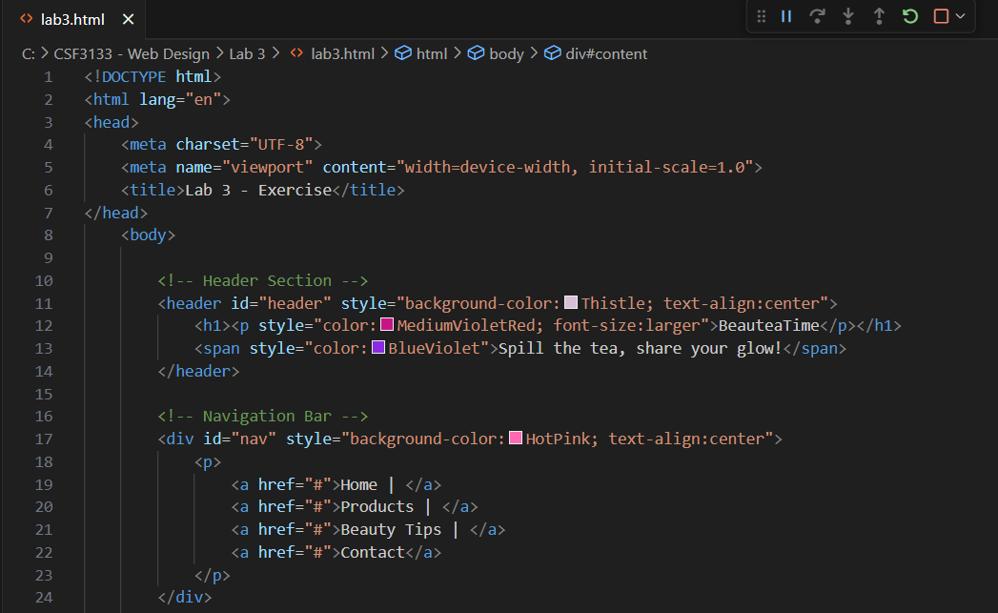
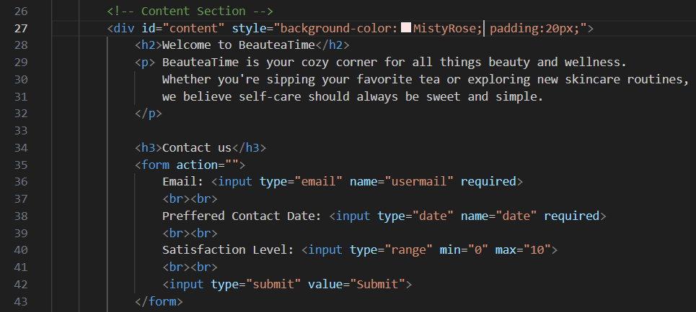
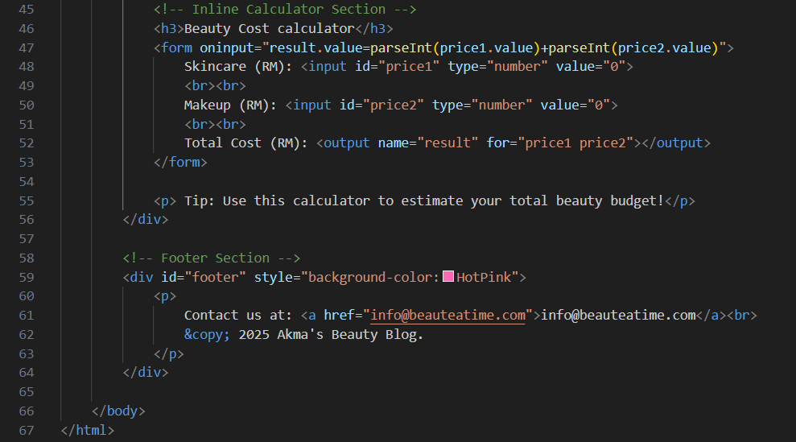

Output:

